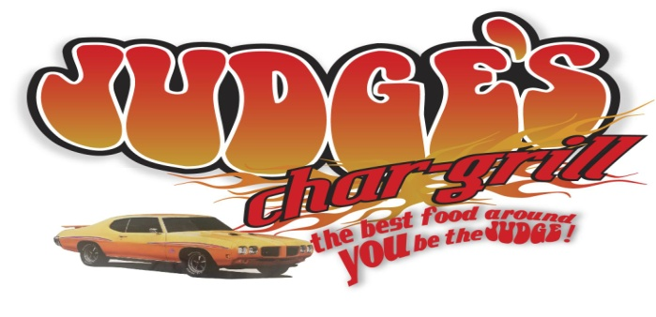

**JUDGE’S CHAR-GRILL**

**proudly presents our charity car/bike/truck show to honor**

***Jennifer Appicello & Justin Waganer and their families***

**Saturday, October 25, 2014 at Judge’s Char-Grill Restaurant**

**10:00 AM – 2:00 PM (registration starts at 9:00)**

**Judging will begin at 12:00 and winners announced at 2:00**

**Registration $25**

**(all proceeds donated to both families and 10% of all food sales for the day)**

**9201 S.E. 29th St.**

**Midwest City, OK 73130**

**405-737-2522**

**(East of Douglas on 29th-next to Subway)**

**Jennifer was diagnosed with kidney cancer and Justin with cancerous tumors in his chest. They both are still endurIng surgeries and/or treatment. Cancer affects the whole family…emotionally, physically and financially. This car show is just a small way we**

**can all show our support. Come spend the day with us. Enjoy some cool cars/bikes/trucks, eat some great food and at the same time show your support for Jennifer and Justin and their families. I know I speak for the families when I say**

**Thank You!!!!!**

*Bike: Custom * Stock*

*Mustang: 1971 and earlier * 1972 and later*

*Corvette: 1971 and earlier * 1972 and later*

*Camaro 1971 and earlier * 1972 and later*

*Truck: 1971 and earlier * 1972 and later*

*Muscle: 1971 and earlier * 1972 and later*

*Vehicles 1971 and earlier * 1972 and later \**

*Convertible*

Import

Special Interest Street Rod

Best of Show

People’s Choice

*Category if you don’t fall in the other classes

1st and 2nd place for each class

Registration form available at Judge’s Restaurant or on Judge’s Char-Grill Facebook Page