Classic Cars of Ponca City
32nd Annual Show -N- Shine Sept 12, 2015

Car Show 8am to 3pm at Hutchins Memorial 5th & Overbrook Ponca City, OK
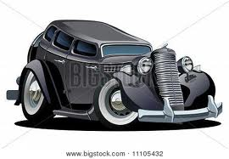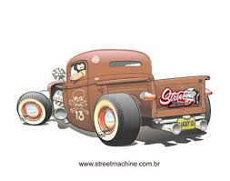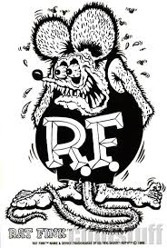

$15.00 Entry Fee Goody Bags & Dash plaques to first 100 entries

Registration 8am-12pm 50/50 Pot Door Prizes

Food Vendors Cash Prizes

Awards

Best of Show Top 15 Best Paint

Best Engine Best Interior Best Unfinished

Best Convertible Best Muscle Car Best Kustom

Best Truck Best Original Best Hot Rod

CCPC not responsible for accidents and/or theft.

Info call Doug Long 580-762-5572 or Guy Anderson 580-765-8514.

Check us out on Facebook at Classic Cars of Ponca City.

