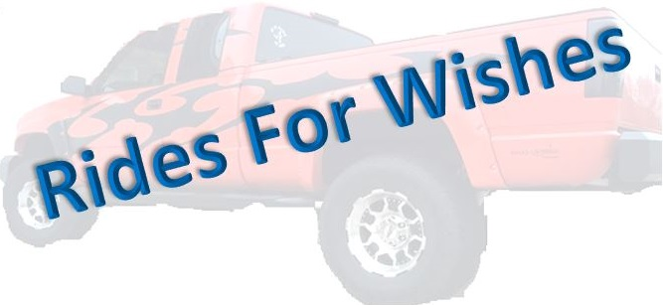

2nd Annual Car, Truck, & Bike Show
Hooters of South OKC
August 1, 2015
12pm-6pm
$20 registration
Trophies to1st & 2nd in Each Category
Raffle & 50/50 Pot
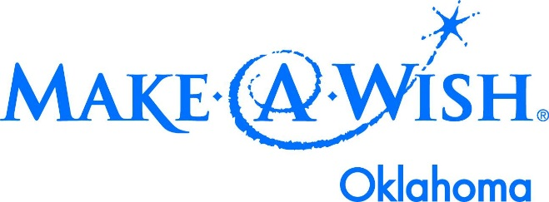
All proceeds go to granting wishes of children with life threatening illnesses through
Make A Wish Oklahoma
Contact Hunter Brown for questions
405-227-7199

