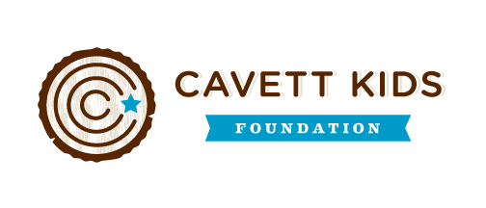
Car Show for Cancer
Sponsored by Maddie’s Mission
- Entry Fee – Donations. All proceeds will be donated to the Cavett Kids foundation.
- When? Saturday, June 13th @ 9:00 am
- Where? Tri-City behind Braums
- For more information Call Devon @ 405-308-0826 or Stacy @ 405-630-9944
